Exercise section15

Mehrab Atighi

11/18/2021

knitr::opts_chunk$set(echo = TRUE)  
library(MASS)  
library(haven)  
library(ggplot2)  
data<-as.data.frame(read_spss("F:/lessons/Multi countios Variate2/data/Table 8.3 football.sav"))  
head(data)

## group WDIM CIRCUM FBEYE EYEHD EARHD JAW  
## 1 1 13.5 57.15 19.5 12.5 14.0 11  
## 2 1 15.5 58.42 21.0 12.0 16.0 12  
## 3 1 14.5 55.88 19.0 10.0 13.0 12  
## 4 1 15.5 58.42 20.0 13.5 15.0 12  
## 5 1 14.5 58.42 20.0 13.0 15.5 12  
## 6 1 14.0 60.96 21.0 12.0 14.0 13

m1 = lda(data$group ~ . , data = data)  
m1

## Call:  
## lda(data$group ~ ., data = data)  
##   
## Prior probabilities of groups:  
## 1 2 3   
## 0.3333333 0.3333333 0.3333333   
##   
## Group means:  
## WDIM CIRCUM FBEYE EYEHD EARHD JAW  
## 1 15.20 58.93700 20.10833 13.08333 14.73333 12.26667  
## 2 15.42 57.37967 19.80333 10.08000 13.45333 11.94333  
## 3 15.58 57.77000 19.81000 10.94667 13.69667 11.80333  
##   
## Coefficients of linear discriminants:  
## LD1 LD2  
## WDIM 0.948423100 1.4067750094  
## CIRCUM -0.003639865 -0.0005126312  
## FBEYE -0.006439599 -0.0286176430  
## EYEHD -0.647483088 0.5402700415  
## EARHD -0.504360916 -0.3839132257  
## JAW -0.828535064 -1.5288556226  
##   
## Proportion of trace:  
## LD1 LD2   
## 0.943 0.057

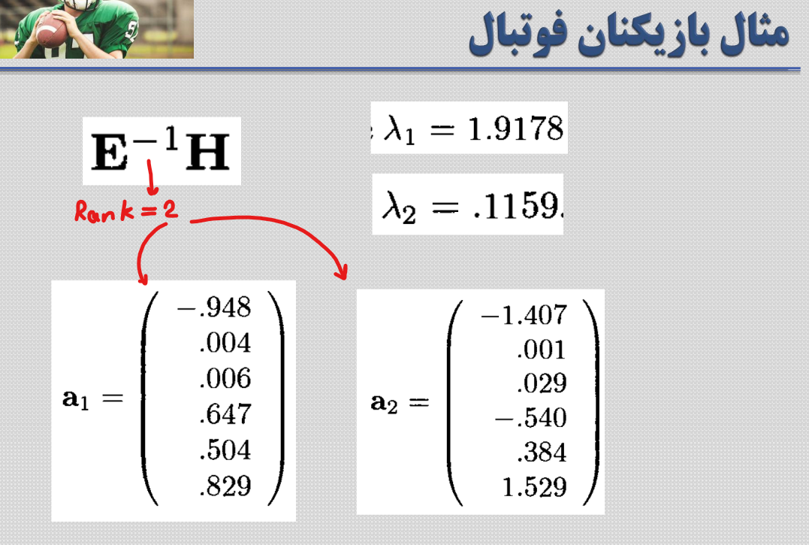

plot(m1)

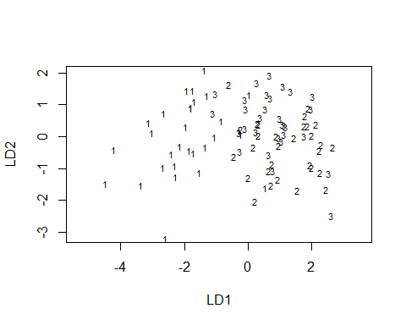

pp = predict(m1)  
dd= data.frame(LD1 = pp $ x [,1] , LD2 = pp $ x [,2])  
ggplot(data = dd , aes(x = LD1 , y = LD2 ))+  
 geom_point(aes (col = factor(data$group)))

